|  |  |  |  |  |  |  |  |
| --- | --- | --- | --- | --- | --- | --- | --- |
| Species | Life Stage | Best Model |  |  |  |  | Deviance Explained |
| Alaska Plaice | Egg |  | 0.149 | 0.0171 | 463.75 | 49.461 | 75% |
| Larvae |  | 0.151 | 0.0701 | 403.40 | 173.051 | 82.9% |
| Rex Sole | Egg |  | 0.188 | 0.0962 | 647.63 | 312.892 | 63.2% |
| Walleye Pollock | Egg |  | 0.147 | 0.0193 | 620.57 | 76.403 | 59.2% |
| Larvae |  | 0.136 | 0.0073 | 530.67 | 20.893 | 71.4% |
| Yellowfin Sole | Larvae |  | 0.194 | 0.0714 | 569.00 | 190.364 | 83.8% |
| Flathead Sole | Egg |  | 0.179 | 0.0115 | 901.13 | 46.555 | 76.2% |
| Larvae |  | 0.112 | 0.0115 | 192.76 | 58.715 | 61.8% |
| Pacific Cod | Larvae |  | 0.094 | 0.0576 | 229.84 | 142.916 | 72.8% |
| Northern Rock Sole | Larvae |  | 0.118 | 0.0467 | 344.99 | 118.067 | 69.9% |

*MSE was calculated by subtracting best model MSE from base model MSE, therefore positive values indicate a reduction in MSE relative to the base model. AIC was calculated the same way, thus positive differences in AIC indicate a reduction in AIC relative to the base model.

1. The second best-performing model for Alaska plaice eggs was the variable-coefficient geography formulation: (log(Catch per 10m2)+1) = *factor*(year) + *s*(doy) + *s*(bottom depth, k=5) + *g*(lon, lat, by = variable regional SST) + *e*doy,year,(lon,lat). The second best-performing model for larvae was the individual additive temperature and salinity formulation: (log(Catch per 10m^2 )+1)=factor(year) ~ s(doy,k=5) + s(bottom depth) + s(salinity) + s(temperature)+ *e*(doy,year,(salinity,temperature)).

2. The second best-performing model for rex sole eggs was the variable-coefficient geography formulation: (log(Catch per 10m2)+1) = *factor*(year) + *s*(doy) + *s*(bottom depth, k=5) + *g*(lon, lat, by = variable regional SST) + *e*doy,year,(lon,lat).

3. The second best-performing model for walleye pollock eggs was the variable-coefficient geography formulation: (log(Catch per 10m2)+1) = *factor*(year) + *s*(doy) + *s*(bottom depth, k=5) + *g*(lon, lat, by = variable regional SST) + *e*doy,year,(lon,lat). The second best-performing model for larvae was the individual additive temperature and salinity formulation: (log(Catch per 10m^2 )+1)=factor(year) ~ s(doy,k=5) + s(bottom depth) + s(salinity) + s(temperature)+ *e*(doy,year,(salinity,temperature)).

4. The second best-performing model for yellowfin sole larvae was the individual additive temperature and salinity formulation: (log(Catch per 10m^2 )+1)=factor(year) ~ s(doy,k=5) + s(bottom depth) + s(salinity) + s(temperature)+ *e*(doy,year,(salinity,temperature)).

5. The second best-performing model for flathead sole eggs was the variable-coefficient phenology formulation: (log(Catch per 10m2)+1) = *factor*(year) + *s*(doy) + *s*(bottom depth, k=5) + *s*(doy, by = variable regional SST) + *e*doy,year,(lon,lat). The second best-performing model for larvae was the individual additive temperature and salinity formulation: (log(Catch per 10m^2 )+1)=factor(year) ~ s(doy,k=5) + s(bottom depth) + s(salinity) + s(temperature)+ *e*(doy,year,(salinity,temperature)).

6. The second best-performing model for Pacific cod larvae was the individual additive temperature and salinity formulation: (log(Catch per 10m^2 )+1)=factor(year) ~ s(doy,k=5) + s(bottom depth) + s(salinity) + s(temperature)+ *e*(doy,year,(salinity,temperature)).

7. The second best-performing model for northern rock sole larvae was the additive temperature formulation: (log(Catch per 10m^2 )+1)=factor(year) ~ s(doy,k=5) + s(bottom depth) + s(temperature)+ *e*(doy,year,(salinity,temperature)).

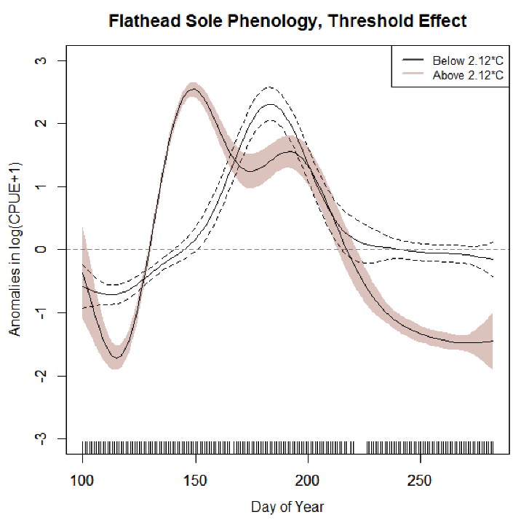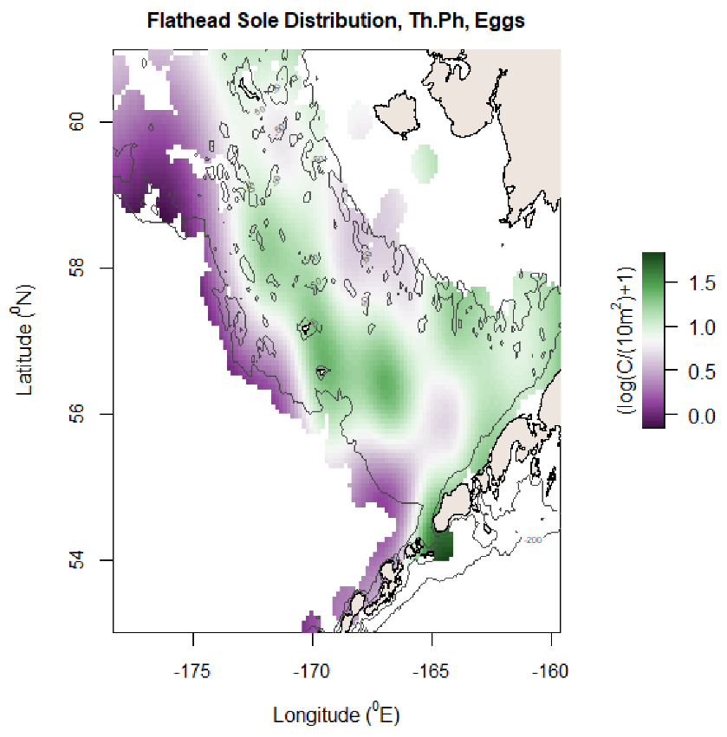

MSE reduction: 0.179, AIC reduction: 901.13, Deviance Explained: 76.2%

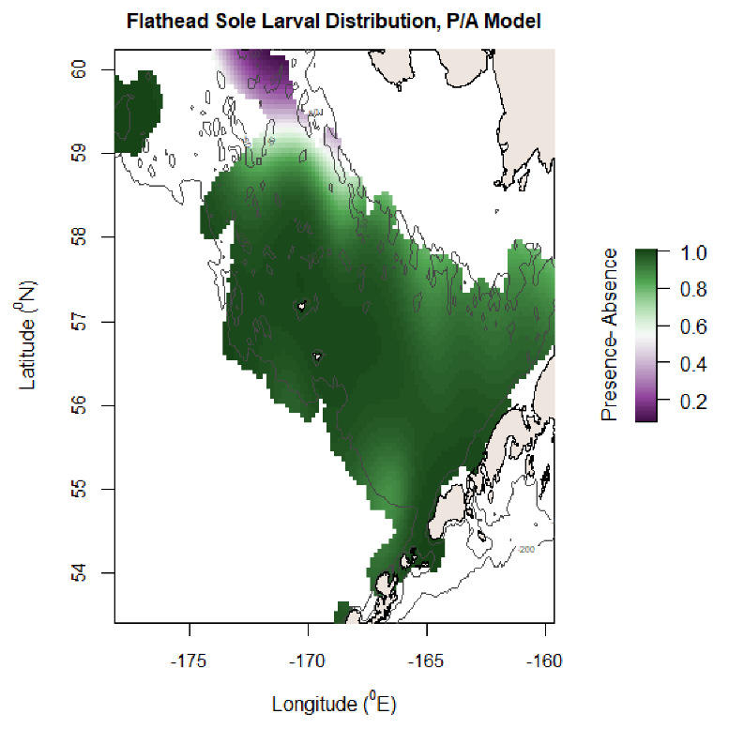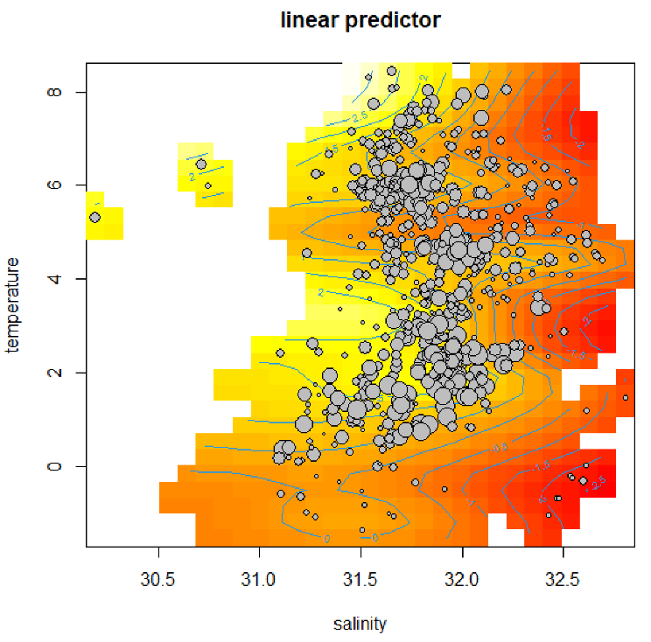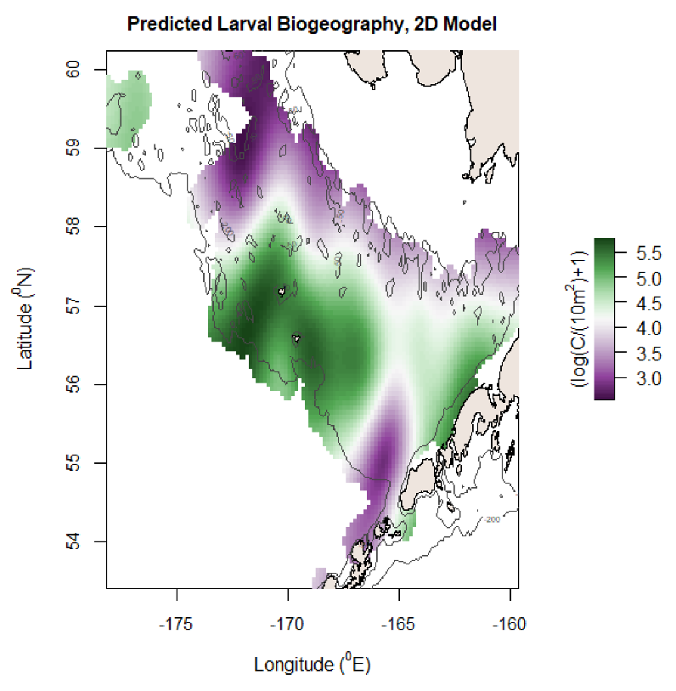

MSE reduction: 0.112, AIC reduction: 192.76, Deviance Explained: 61.8%

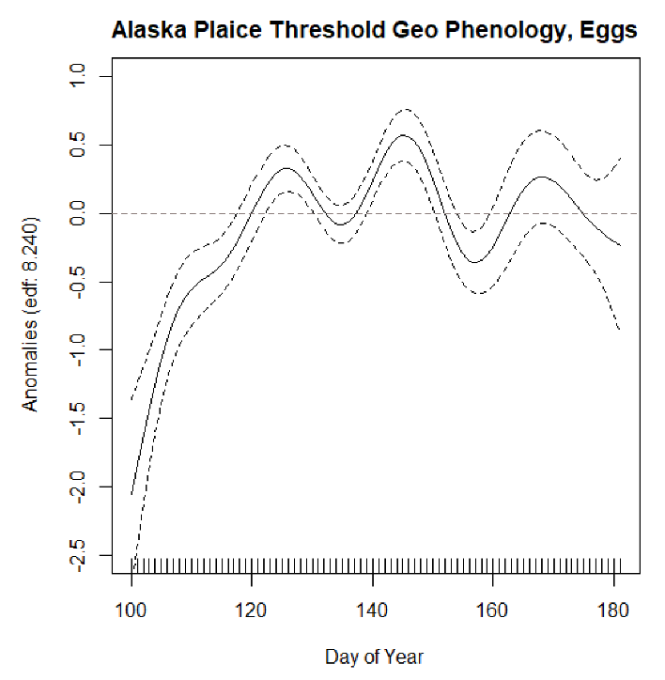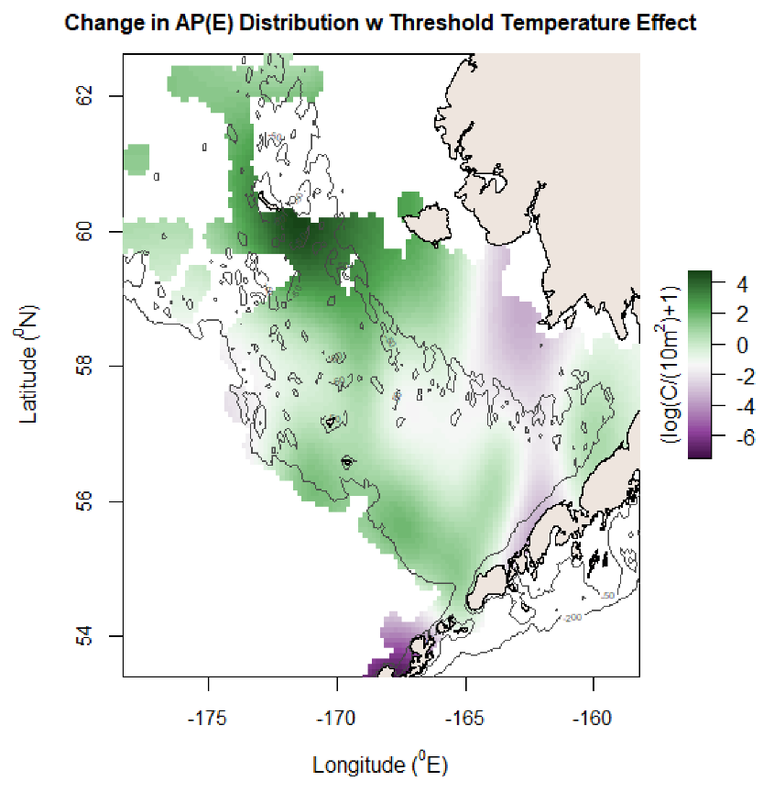

MSE reduction: 0.149, AIC reduction: 463.75, Deviance explained: 75%

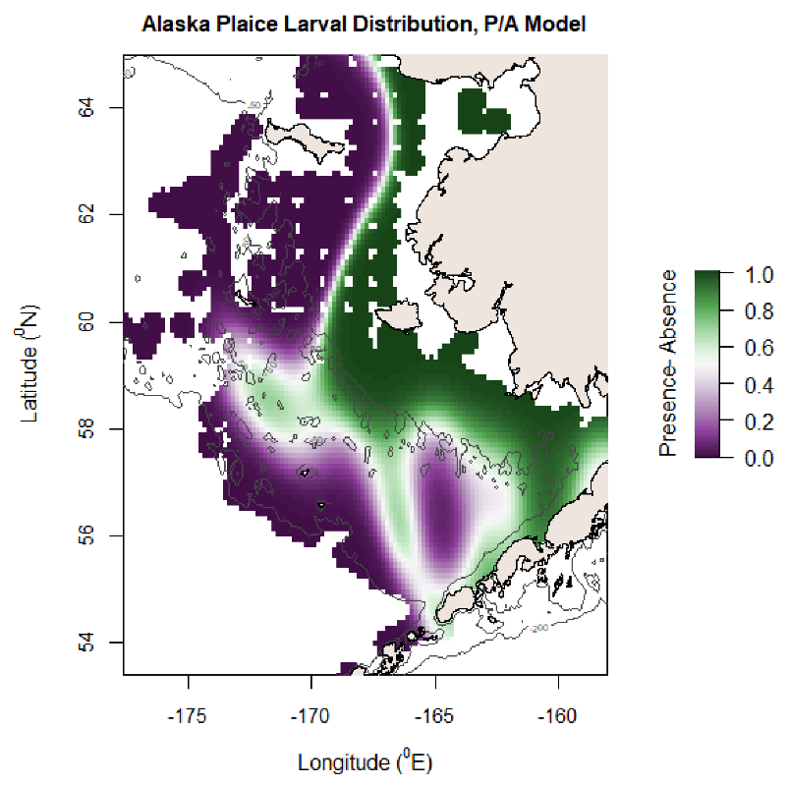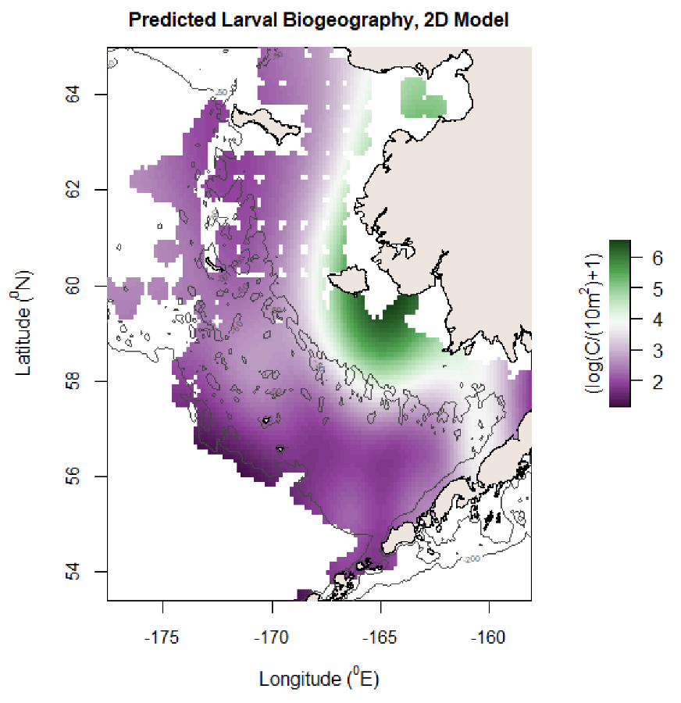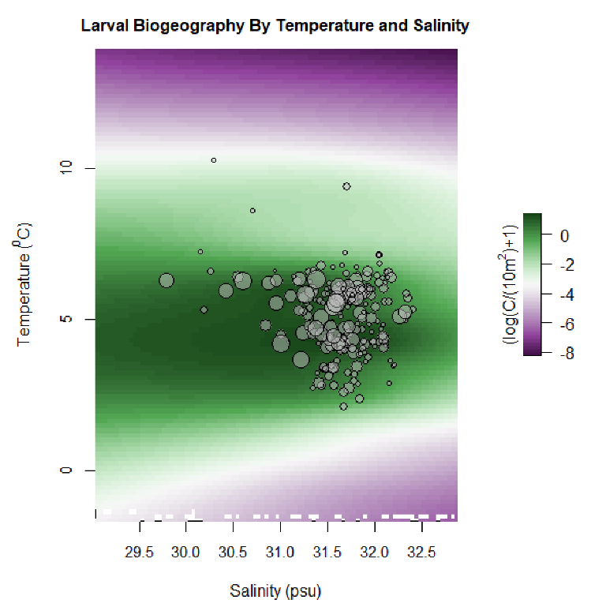

MSE reduction: 0.151, AIC reduction: 403.40, Deviance explained: 82.9%

Additive temp model: Deviance explained 61.9%. Very close tie with 2D model (dev exp of 61.8%, AIC difference of 5.79)

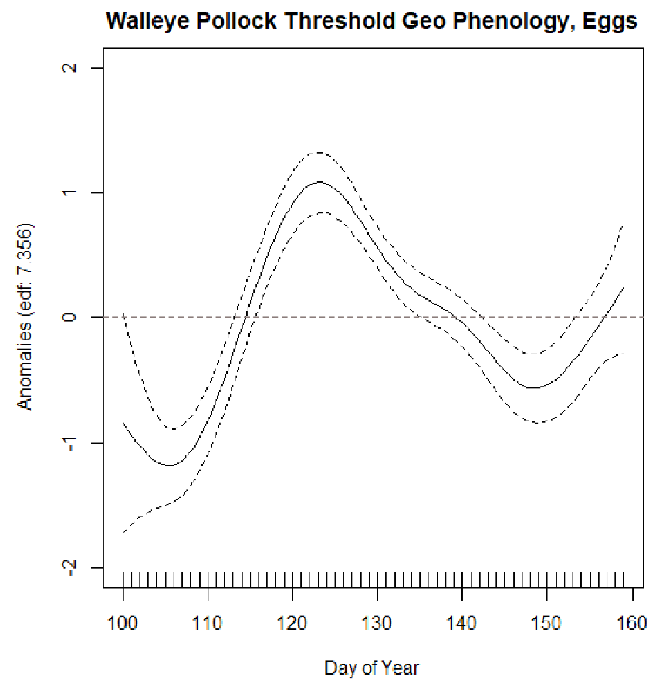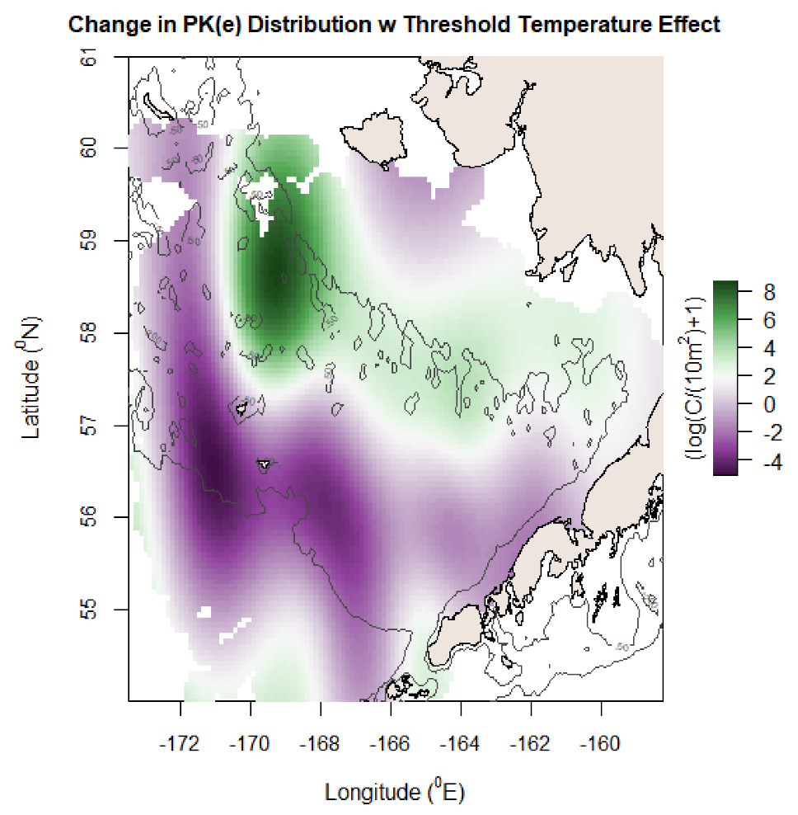

MSE reduction: 0.147, AIC reduction: 620.57, Deviance explained: 59.2%

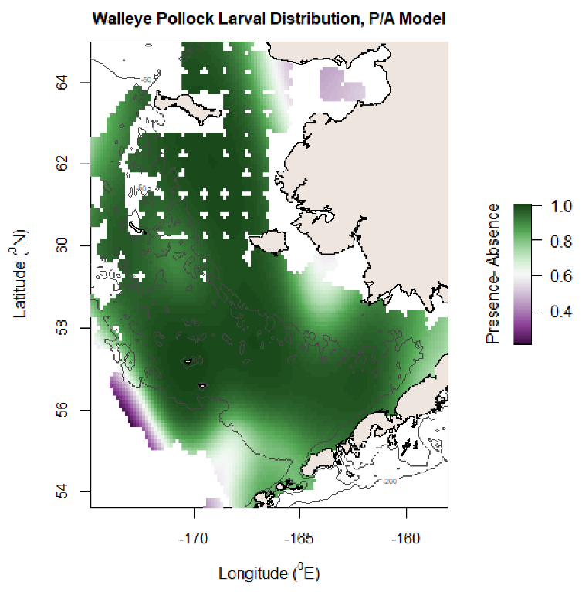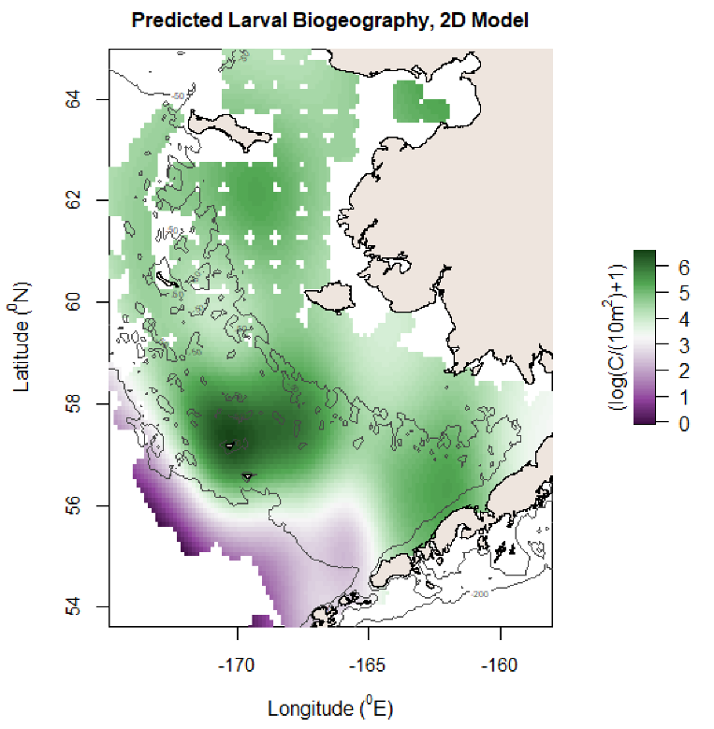

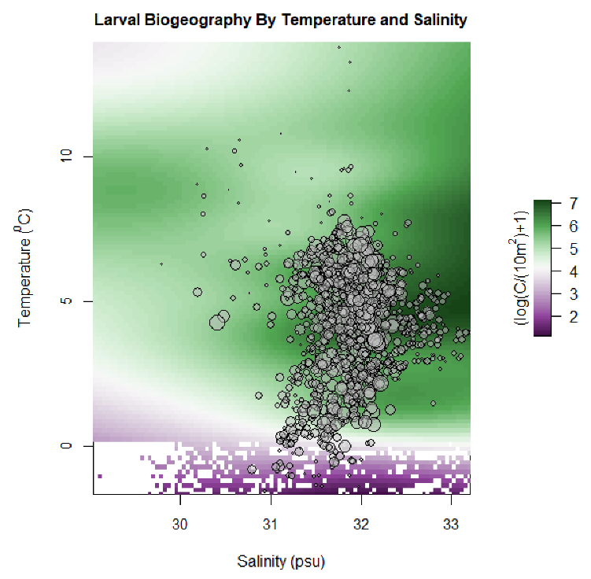

MSE reduction: 0.136, AIC reduction: 531.51, Deviance explained: 71.4%

Deviance explained: 60.4%

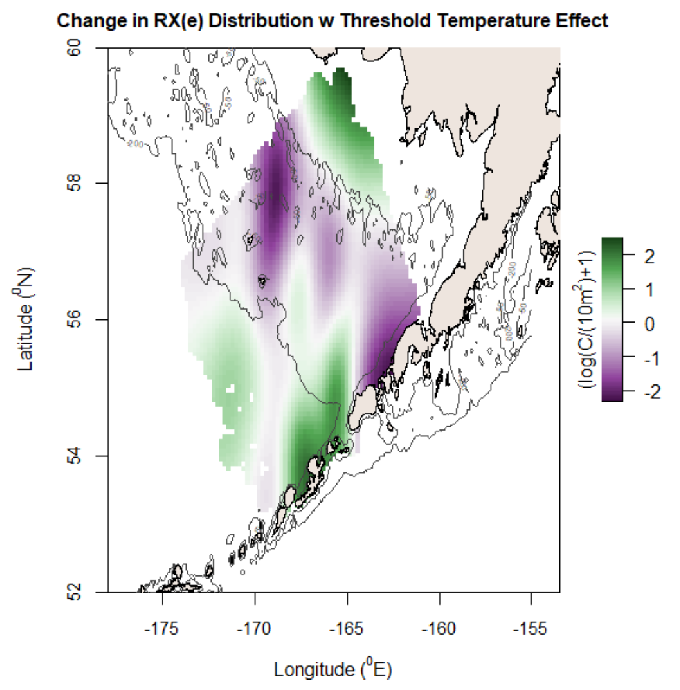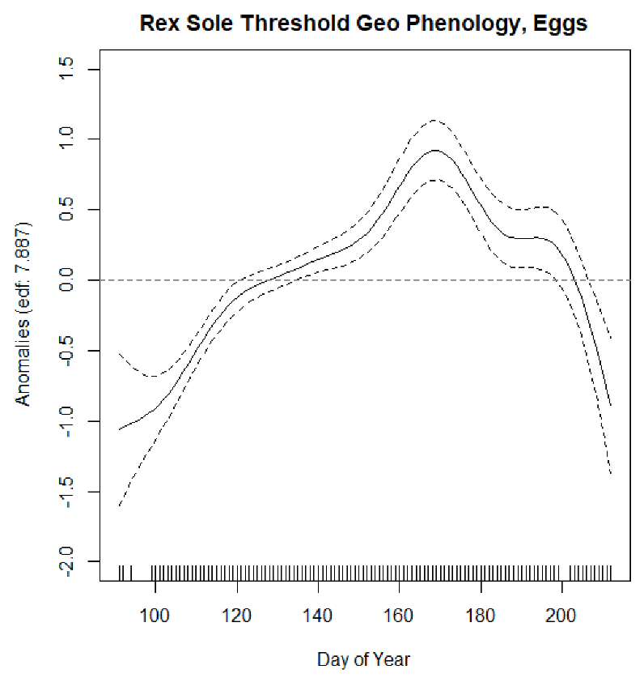

MSE reduction: 0.188, AIC reduction: 647.63, Deviance explained: 63.2%

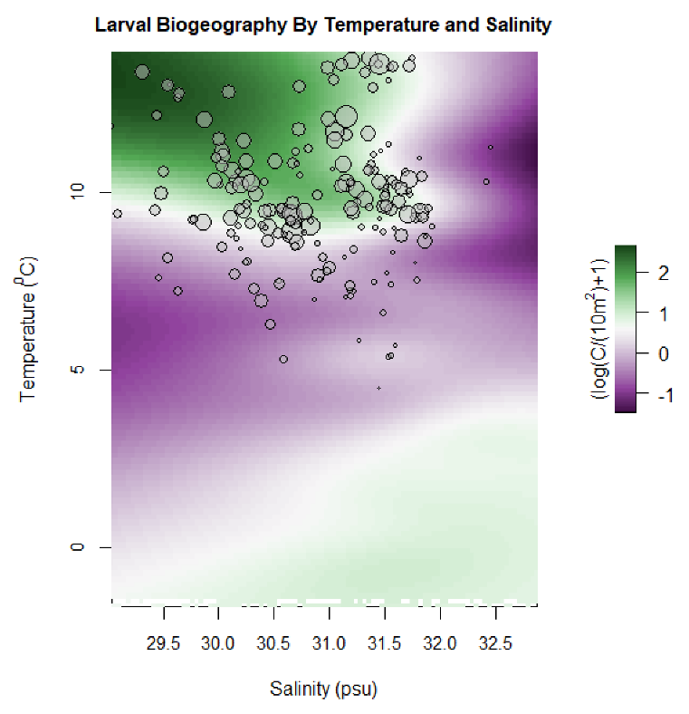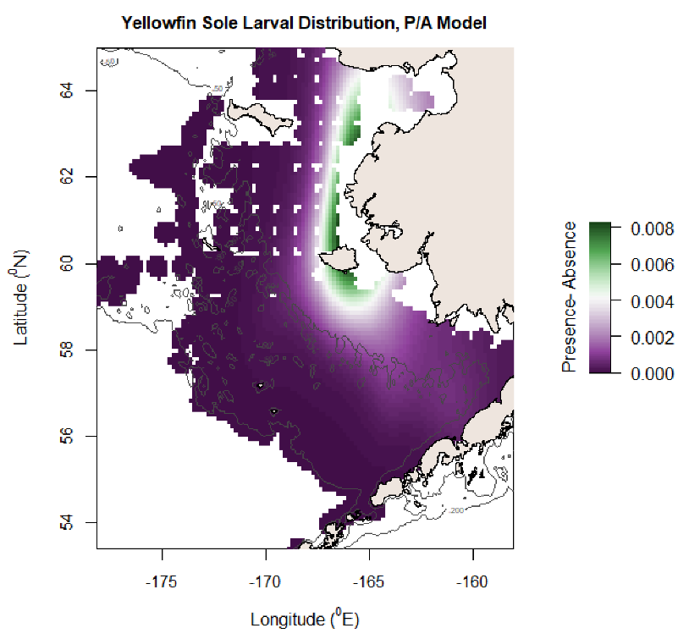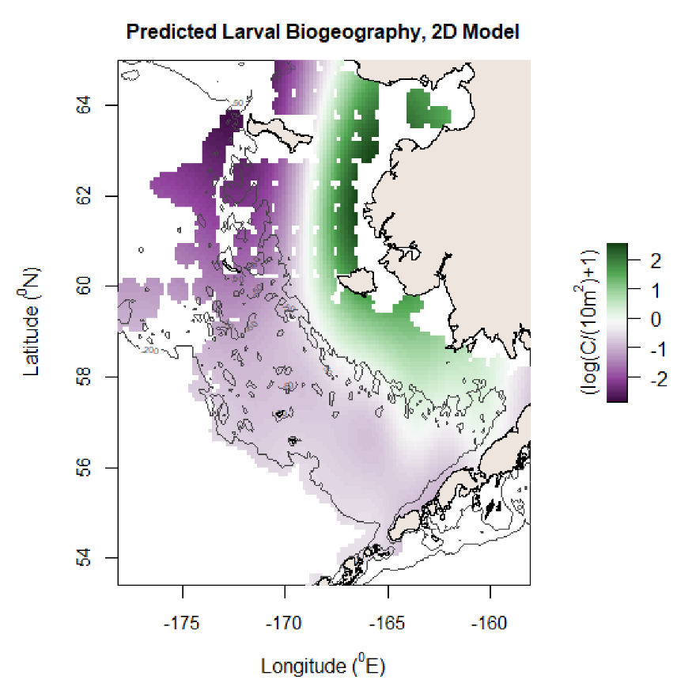

Deviance explained: 72%

MSE reduction: 0.194, AIC reduction: 569.00, Deviance explained: 83.8%

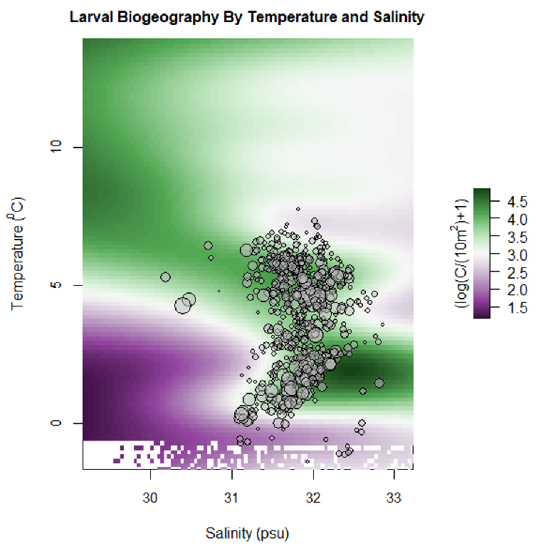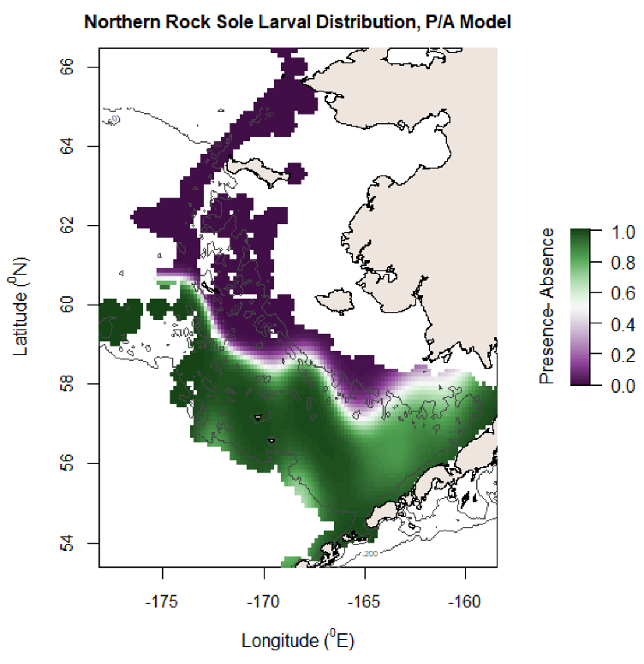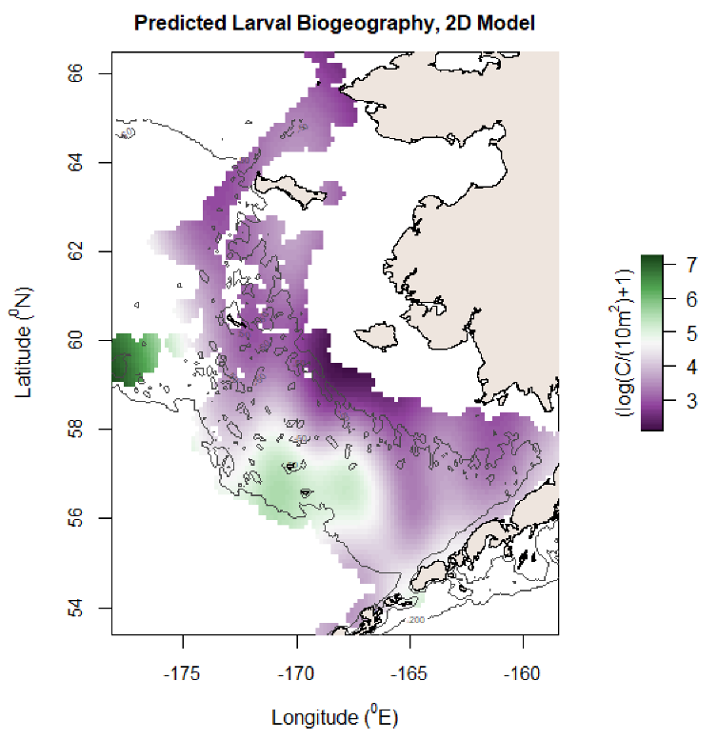

Deviance explained: 53.4%

MSE reduction: 0.118, AIC reduction: 344.99, Deviance explained: 69.9%

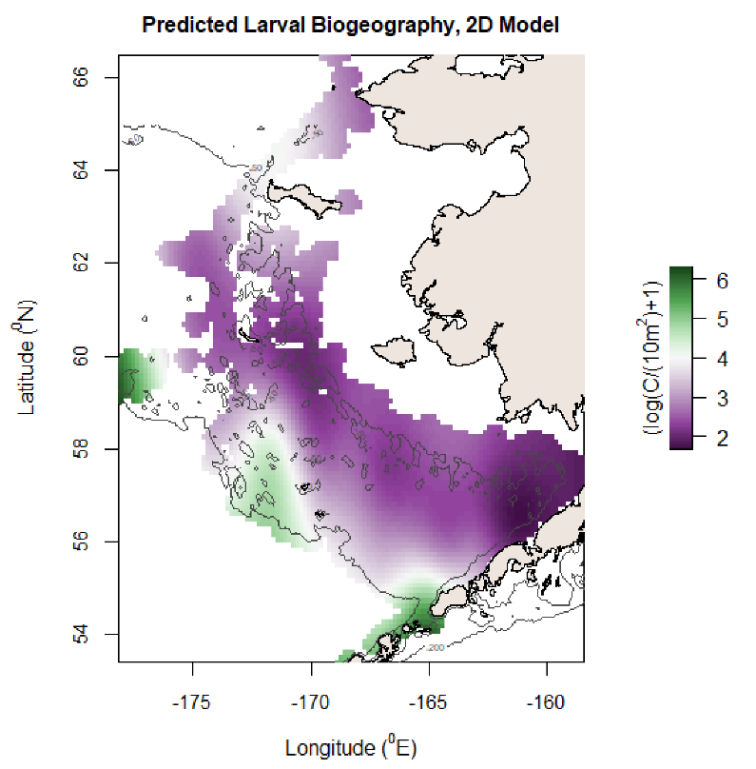

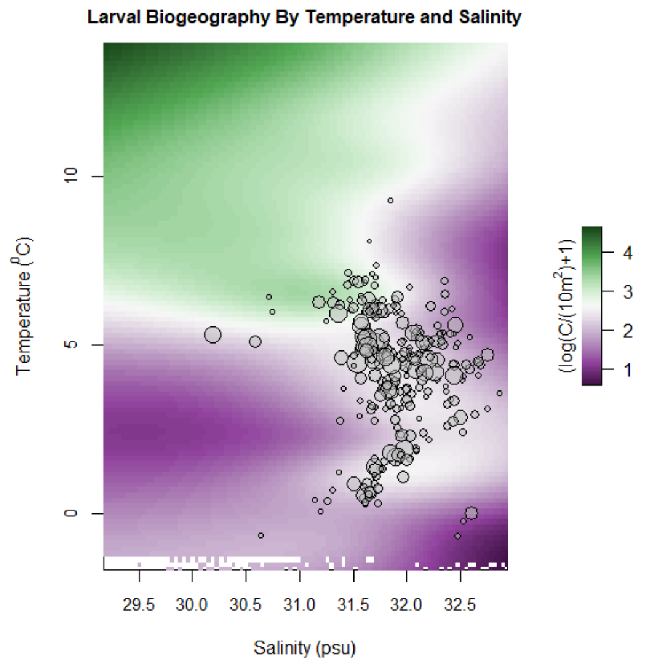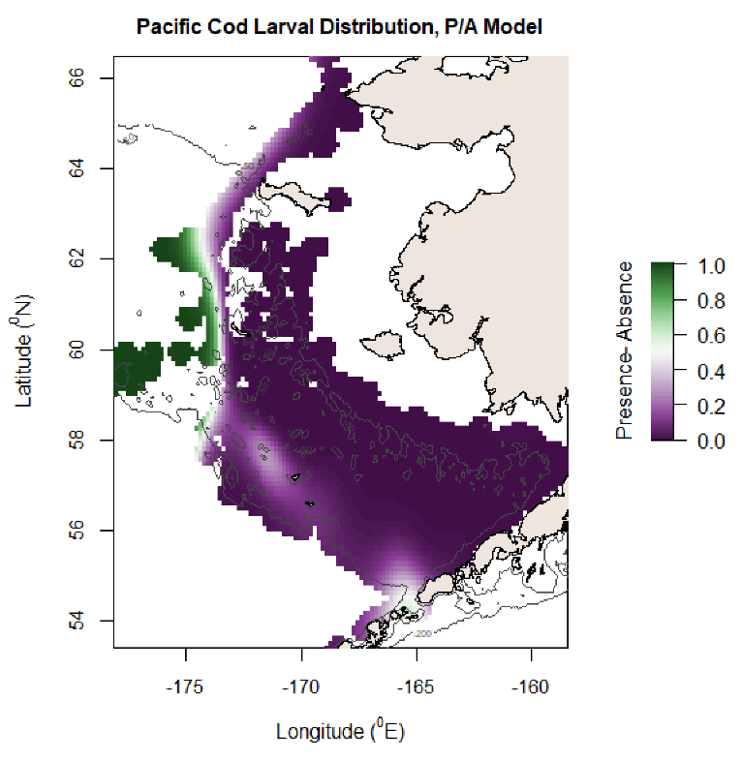

MSE reduction: 0.094, AIC reduction: 229.84, Deviance explained: 72.8%

Deviance explained 54.6%

